CMPG322
Exercise 5.3 – Project crashing
- Bowman Builders manufactures steel storage sheds for commercial use. Joe Bowman, president of Bowman Builders, is contemplating producing sheds for home use. The activities necessary to build an experimental model and related data are given in the following table:
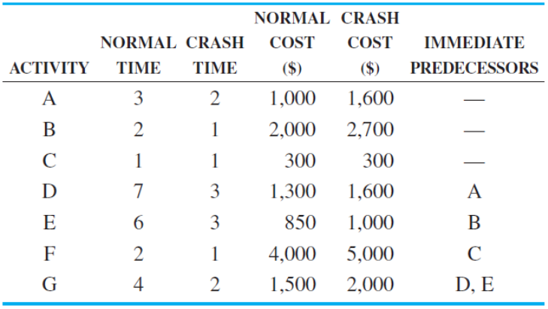
- Which activity(ies) must be crashed to complete this project in 10 weeks an what will the cost be?
- Use your answer in a) and determine the new critical path(s).

- The Scott Corey accounting firm is installing a new computer system. Several things must be done to make sure the system works properly before all the accounts are put into the new system. The following table provides information about this project.
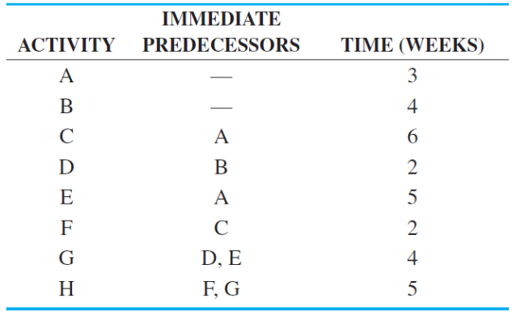
- How long will it take to install the system? What is the critical path?
- The managing partner of the Scott Corey accounting firm has decided that the system must be up and running in 16 weeks. Consequently, information about crashing the project was put together and is shown in the following table:
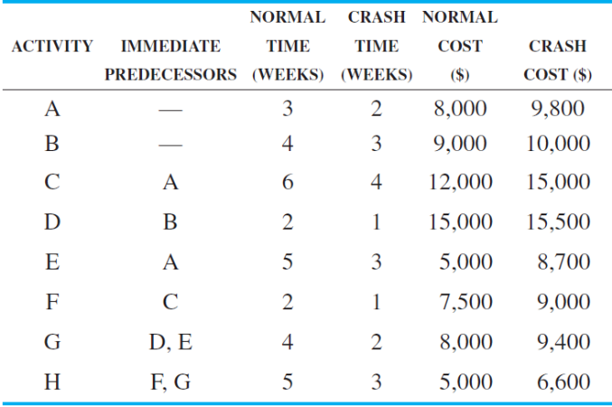
If the project is to be finished in 16 weeks, which activity or activities should be crashed to do this at the least additional cost? What is the total cost of this? What is the new critical path?

- The Laurenster Corporation needs to perform the tasks in the following list:
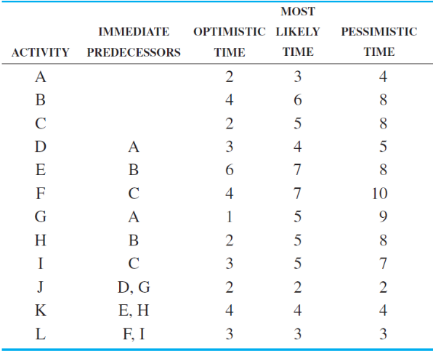
It has determined the client will pay it a $10,000 bonus if it completes the project in 14 weeks or less. The associated normal times and costs as well as the crash times and costs are shown below.
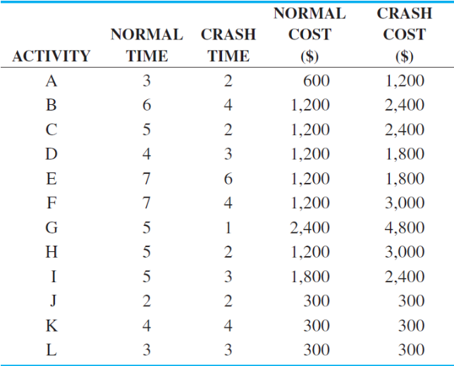
Considering the costs involved to crash the project, determine if the Laurenster Corporation should crash the project to 14 weeks to receive the bonus.

